**Assignment Tasks**  
**Question 1.** Retrieve a list of user information with their name and date of registration who uses android phones. First look at the structure of the user_info table in database and then write your query.

**Question 2.** Edit your query above to find out users who have registered on or after 14th of july and sort the list of users in ascending order.

**Solution:**

1. SELECT name, registration_date FROM user_info

WHERE operating_system = 'Android';

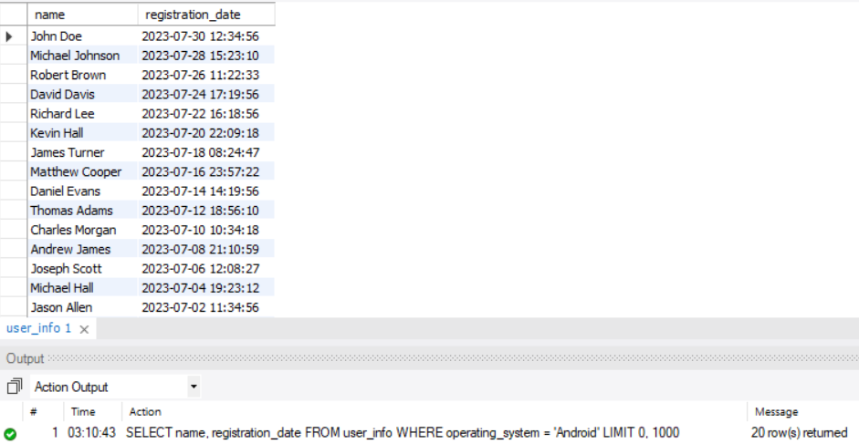

1. SELECT * FROM user_info

WHERE registration_date >= '2023-07-14'

ORDER BY registration_date ASC;

